Write a program to take a number sequence as input and output all possible letter combinations that can be represented by that number sequence on the phone.

Problem Solving

**Objective**

Given an input string containing digits between 2 and 9 (both included), find and print all the letter combinations that number could represent.

The mapping can be seen here

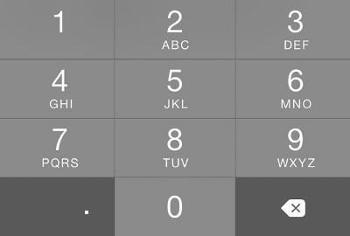

Note: The output needs to be lexicographically sorted. Some digits can represent 4 characters.

**Examples**

**Example 1**

Input: 34

Output: dg dh di eg eh ei fg fh fi

**Example 2**

Input: 234

Output: adg adh adi aeg aeh aei afg afh afi bdg bdh bdi beg beh bei bfg bfh bfi cdg cdh cdi ceg ceh cei cfg cfh cfi